

**University of Edinburgh**

**School of Geosciences**

Evaluating Forest cover change in red panda (*Ailurus Fulgens*) habitat from 2000 – 2018

*By*

Cameron Cosgrove

In partial fulfilment of the requirement for the

Degree of BSc with Honours in Ecological and Environmental Science

April 2019

# Abstract

Habitat loss has consistently been identified as the largest threat facing the endangered red panda. Low dispersal capabilities, arboreal lifestyle, and narrow distribution also make red pandas particularly susceptible to reproductive isolation cause by habitat fragmentation. For the first time, this dissertation quantifies the extent of forest loss across the red pandas entire range, and maps the areas of low and high habitat disturbance. My results estimate an area of XXX km2 of forest habitat has been lost since 2000 - 2018. The XXX area and the YYY area show the most pronounced forest loss. No countries show a net increase in forest from 2000 - 2012 in red panda habitat. Protected areas sufficiently/insufficiently protect forest. Habitats at lower elevation show the highest amount of habitat loss, which correlates with higher human population. The forest network in red panda habitat is likely fragmented into 3 isolated populations, with X habitat bottlenecks experiencing moderate to high disturbance. The conservation implications of this work are…

Table of Contents

Abstract 2

Table of Contents 3

Acknowledgements 5

List of abbreviations 6

1. Introduction 7

The red panda 7

Ecology 7

Red panda conservaiton 9

1.3 Project Rationale 9

A remote sensing approach 10

1.4 Research questions and hypotheses 10

What change has occurred to forests in red panda habitat? 11

Where has forest been lost in red panda habitat? 11

2. Methods 11

2.1 Defining the study area 12

2.2 Data collection 12

Global Forest Change Dataset 12

Red Panda distrubution 12

2.3 Data processing 12

Forest Change 12

Hot spot identification 12

2.4 Data analysis 12

3. Results 12

3.1 What change has occurred to forests in red panda habitat? 13

3.2 Where has forest been lost in red panda habitat? 14

14

4. Discussion (Demonstrate Understanding!) 15

Key findings 15

4.1 How is Red Panda Habitat changing? 15

4.2 Conservation implications 15

4.3 Limitations 15

What needs to be considered when interpreting my results? 15

4.4 Future work 15

5. Conclusion 16

6. References 16

7. Appendices 16

Acknowledgements

List of abbreviations

GEE – The google earth engine

MaxEnt – Maximum entropy distribution model

IUCN

CITIES

GFC – Global forest change dataset

1. Introduction

Terrestrial mammal populations are changing rapidly around the world. Mammal Populations are both increasing and decreasing, primarily driven by human activity such as hunting and ecosystem modification. SOME DATA FROM A STUDY WOULD BE NICE HERE. This is of concern for a number of ethical, practical, and aesthetic reasons. Much attention is given to reversing these changes and finding evidence based solutions for mammal conservation, particularly for preventing species extinction. Species conservation plans require data to make informed decisions, yet data are often unavailable due to the remoteness of field sites. Creating methods that can quickly measure and monitor relevant ecosystem variables is of great use for conservation planning and action. Remote sensing tools such as satellite imagery are being used to gather relevant data for conservation and can be used to inform smart conservation action.

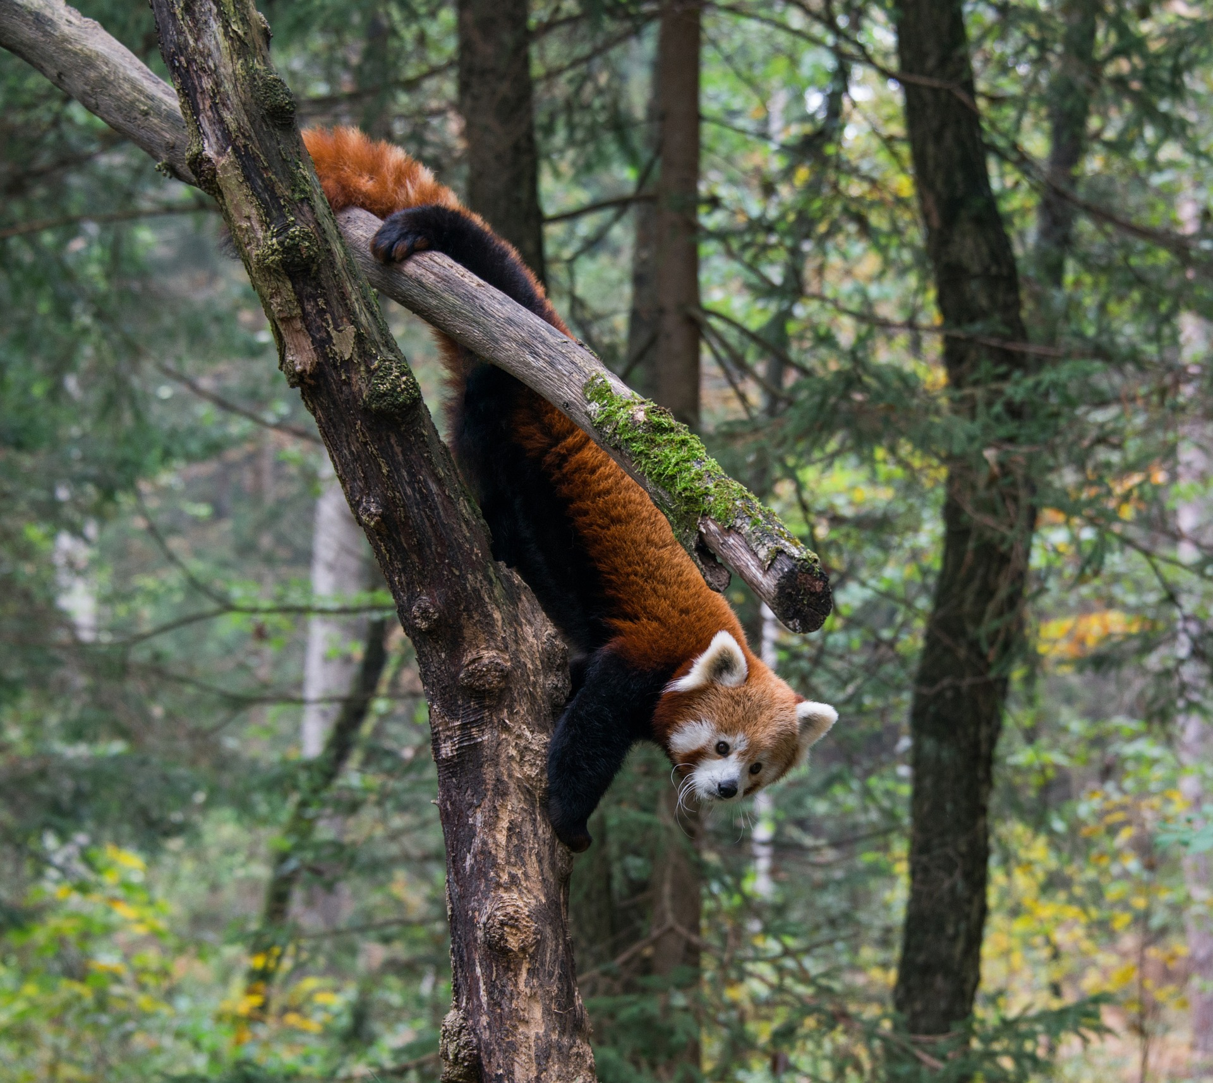Expanding human populations are encroaching into a range of habitats, increasing the magnitude of ecosystem modification. Out of the many ways human modify their environment, land use change and habitat fragmentation have the largest impact on mammal populations. Species with narrowly defined niches and low dispersal capabilities show the most significant population declines in response to these changes. In addition, large arboreal mammals suffer the largest loss of genetic diversity following forest loss and fragmentation. Mammals that have all of these traits, such as the red panda, are expected to be severely impacted by human caused ecosystem modification, particularly deforestation.

The red panda

Ecology

Red pandas are exacting in their habitat requirements. Attitudinally bound on the southern slopes of the Himalayas, occupying fairly homogenous forests. Species distribution models work well with this species.

Low density and mainly solitary/ Fecundity? Three known isolated populations. Diet

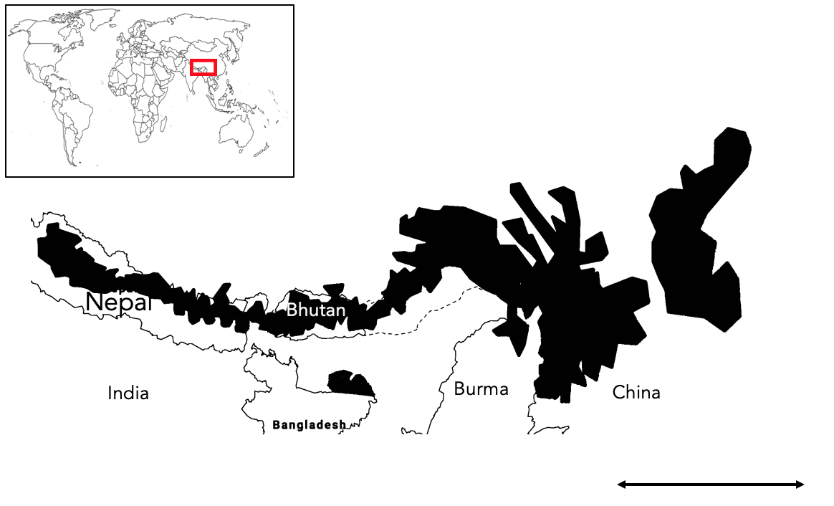

Two genetically distinct populations of red pandas exist. Separated by X river valley. Previously considered a sub species, genetic analysis now suggests they are two distinct species. This taxonomic view is still debated. Slitting the species will have conservation implications and as such I have made a distinction between the two sub species in this dissertation

Conservation efforts

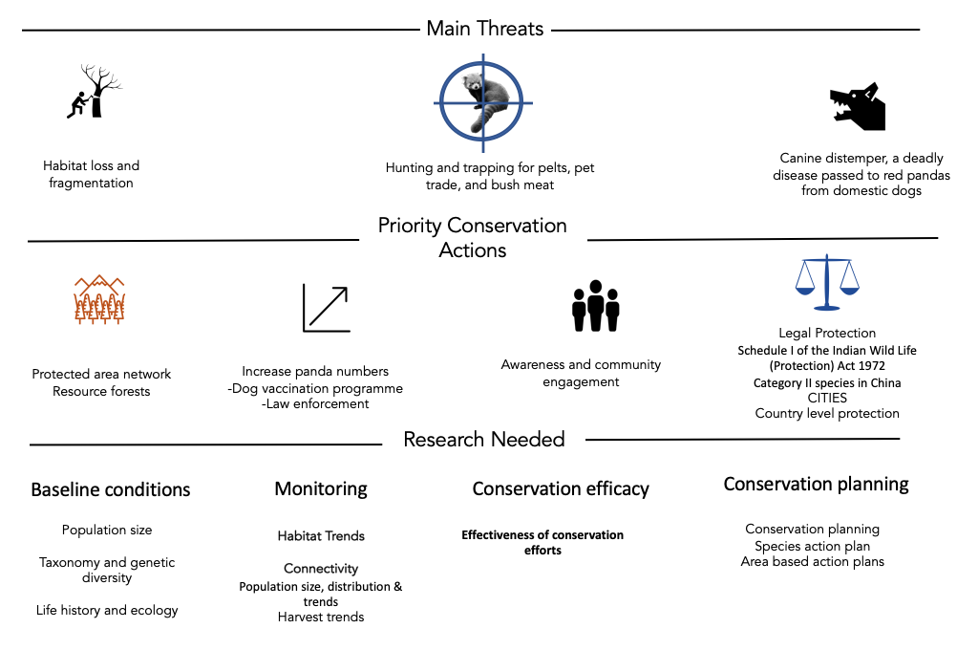Local action. Wide scale measures are not red panda specific. No coordinated range wide management plan exists. I have found it suspiring that there is not more research and conservation interest for the red panda, considering it is cute af. The species primarily suffers from lack of research due to remote distribution, however much of its habitat is now accessible.

1.3 Project Rationale

Knowledge gap. There is a want to develop a range wide transboundary conservation plan for red pandas. This involves:

* identifying the core and most threatened bits of habitat
* Is habitat being lost, if so where
* Is the rate of loss increasing?
* Is the habitat connected? Are there at risk bottle necks
* How are pandas doing in different countries
* Is the protected area network sufficient and how should we protect habitat (corridors like tigers?)

We currently don’t know the big picture of how forest cover is changing. This could lead us to protect the wrong areas or invest resources in inefficient ways. Many of these questions can be answered by pre-existing remote sensing datasets. I think knowing WHAT change is happening to red panda forests and WHERE change is happing would be valuable to conservation decision making process for red pandas. Indeed the IUCN small carnivore group has identified habitat monitoring as the highest priority research topic for red pandas. We already know there is insufficient protected area coverage for red pandas, and there are calls to establish new areas to protect pandas. This assumes current pa’s are working for pandas. I am also interested in seeing if this appears to be the case.

A MaxEnt distribution model for Red Pandas was created in 2018 to help identify where important habitat is. The tight niche of red pandas allows for the reasonable assumption that forest cover represents panda habitat. Doesn’t detect understory bamboo but hey ho. I have made a red panda specific resource and have looked at broad scale patterns.

A remote sensing approach

Advancement in remote sensing technologies now allow for the rapid collection of relevant ecological measurement across a range of environments. Large datasets describing changes in land cover, vegetation structure and moisture levels are all now publically accessible. However, large datasets require large processing power to create and analyse. The creation of cloud based spatial analysis such as the Google Earth Engine in 2013, provide a free platform to conduct analysis on big spatial data. There are a range of conservation opportunities for this data. In particular, the quantification of land use change. Hansen is appropriate for a first assessment of forest change. Good resolution and accuracy for the size or area being looked at too. There is precedent for this approach too. Tiger priority areas have been monitored with this dataset.

In this dissertation, I use publically available forest cover change dataset to evaluate what changing is happening to forest in red panda habitat and identify where this change is happening. Comparisons will be made between conservation relevant aoi’s to gauge large scale trends in the pattern of loss. A map of loss has also been created to qualitatively explore finer scale patterns and provide local information for conservation planning. These results provide

1.4 Research questions and hypotheses

What change has occurred to forests in red panda habitat?

Deforestation is reportedly occurring across the range of the red panda and is stated as one of the most prominent threats to red pandas. Due to the emphasis put on this threat in the literature I expect a sizable about of forest to have been lost across this entire range. The value of 10% has been chosen arbitrarily to represent a sizable amount of loss. I also expect the rate of forest loss to be increasing as the human population in increasing in red panda habitat. I expect the rate of loss to be increasing linearly as this broadly corresponds with the rate of human expansion in the region.

H1: The area of forest in red panda habitat has decreased by 10% from 2000 to 2018 across the entire range.

H0:

Ha:

H2: The rate of forest loss has increased in red panda habitat from 2000 to 2018 across the entire range.

H0:

Ha:

Where has forest been lost in red panda habitat?

H1: Different countries have lost different proportions of forest cover in red panda habitat.

H0:

Ha:

H2: Lower elevations were correlated with higher proportions of forest loss

H0:

Ha:

H3: Core areas of habitat have seen the highest proportion forest loss

H0:

Ha:

H4: Higher IUCN ratings have lost the least proportion forest compared to lower IUCN ratings and unprotected areas.

H0:

Ha:

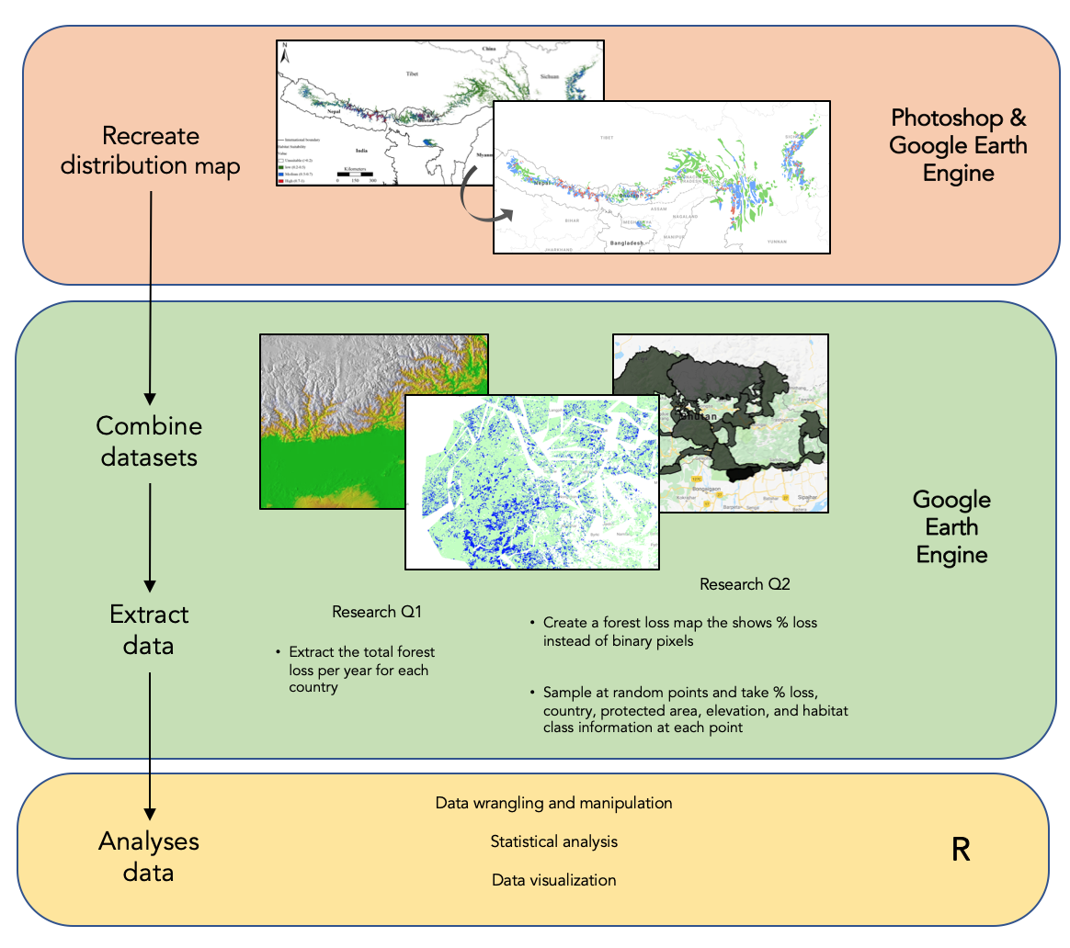2. Methods

Defining the study area

The best data on red panda distributions comes from a 2018 MaxEnt model. The model used climactic, terrain, and weather variables alongside location records of red pandas to create the distribution. The accuracy of XX was stated by the authors and I am comfortable that the map represents the true panda distribution well. I have conducted my analysis within the regions defined by this study. Three habitat classes were mapped: Low 20-40%, Moderate, and Core. I used Photoshop to remap the distribution map onto the base layer of google earth engine, in effect geo-referencing the image by hand using country borders as control points. Polygons were then created on GEE to represent the different habitat classes. This will have resulted in the miss mapping of some panda habitat. However, visual assessment of my map shows good coverage of likely habitat. I further refined this map by clipping the image to >20% forest cover to better reflect red panda habitat.

2.2 Data collection

Datasets

All data used in this dissertation came from pre-existing and publically available datasets detailed in table 1. Each dataset was imported into the google earth engine and was pre-georeferenced.

The Hansen forest loss data was processed from Landsat imagery and classes any vegetation over 5m in height as a forests. Loss was only recorded if the entire pixel transitions from forest to no forest, with gain being the inverse. Forest gain was only available as a cumulative layer up to 2013. The algorithm used to process the landsat imagery was recently updated by Hansen et al to better detect small scale forest loss from 2013 – 2018.

|  |  |  |
| --- | --- | --- |
| Dataset | Source | Description |
| Hansen V1.6 |  | The image gives a binary layer for loss no loss for 2000 – 2018 (each a separate band) and a cumulative image for the entire range. It |
| Elevation |  |  |
| WDPA |  |  |
| Country polygons |  |  |

Analysis in the Earth Engine

All analysis was conducted using the native scale of the gfc dataset. For all loss data, the image(s) were clipped to >20% forest cover measured at 2000 to better reflect panda habitat.

RQ1

Yearly forest loss bands were selected and grouped together using ee.Group.

A reducer function was then used to sum the loss pixel fore each country

Code snippet?

**RQ2**

Creating the forest loss map

I transformed the binary Hansen forest loss data into a map where each pixel represents the average forest loss within 1km2 buffer. I did this for two reasons: i) It is easier to visualise the data and see areas of high forest disturbance and ii) It provides more information on the magnitude of loss at a sample site. A mean neighbourhood circular kernel was used to convolve the image.

I created my own image collection merging the forest loss map, country data, elevation, pa coverage, and habitat class. Every data from a table was transformed into an image by clipping a land mask to its bounds.

In order to gauge the variation in forest loss within areas of interest, I used a sample based approach. 5000 random samples were taken by reducing over randPoints. This number was deemed to be the maximum number of samples without significant overlapping of sample counts, reducing double counting.

2.3 Data processing

The outputs of the earth engine scripts were export as CSV files and loaded into excel for first data cleaning. levels merged into one column and accessory and unwanted metadata for each file was removed.

in excel and then imported into R

% calculation

filtering to get rid of samples in areas less than <20% forest and in any overlapping habitat classes caused by me being a dumbass and not drawing my polygons well.

2.4 Data analysis

Statistical approach. A priori model creation, biological relevance.

Statistical treatment

Assumption assessment

R version

3. Results

3.1 What change has occurred to forests in red panda habitat?

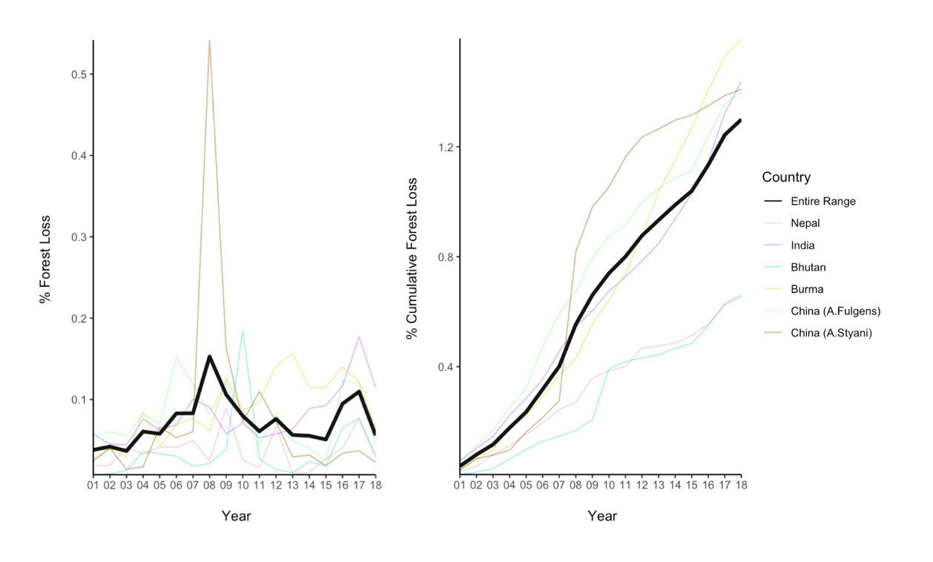Look into un balanced samples

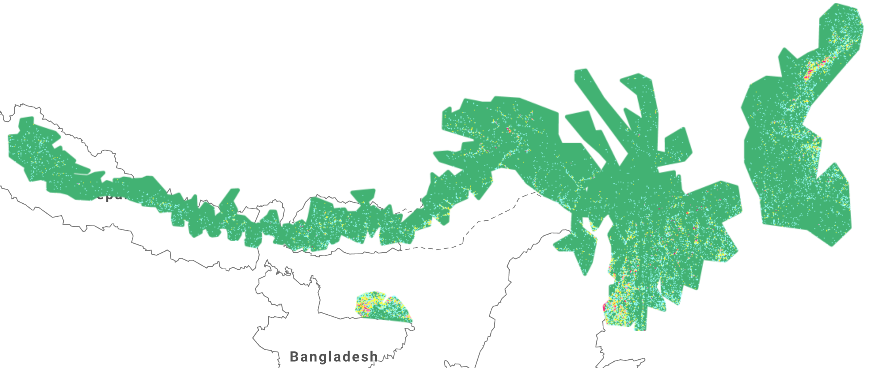3.2 Where has forest been lost in red panda habitat?

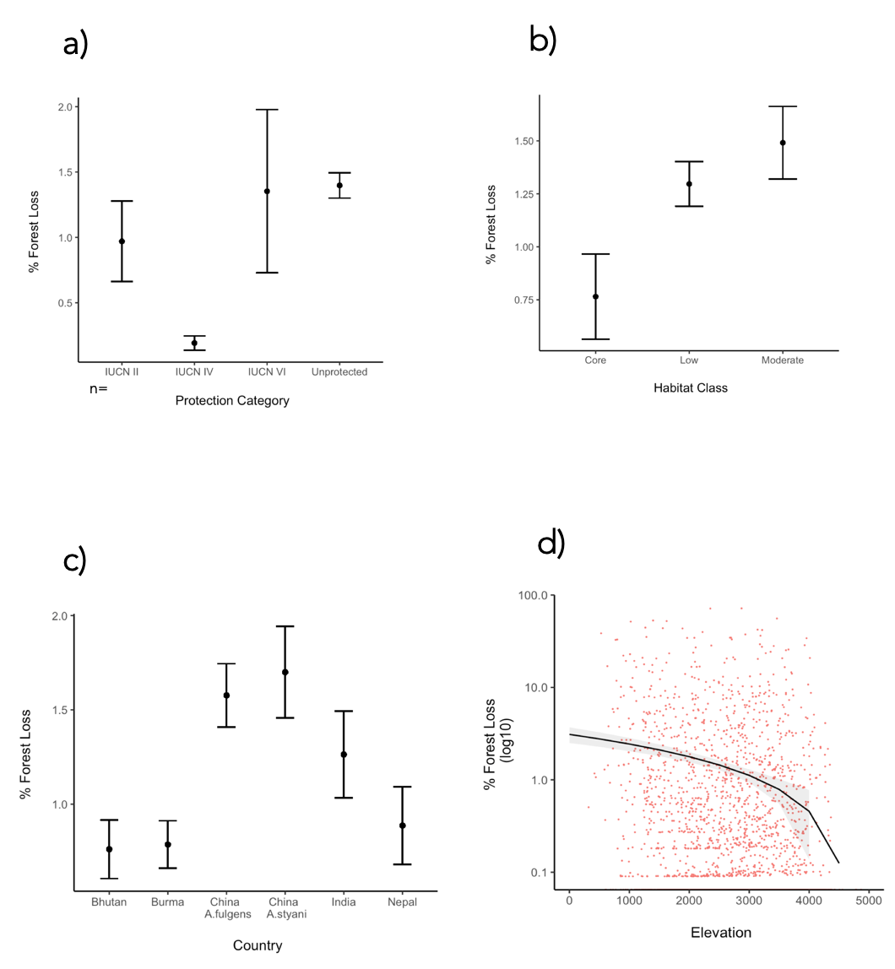

Figure 4

4. Discussion (Demonstrate Understanding!)

Key findings

2-4 points

Highlight what wasn’t known before

4.1 How is Red Panda Habitat changing?

How do these results compare to on the ground studies?

4.2 Conservation implications

4.3 Limitations

What needs to be considered when interpreting my results?

PA analysis should look at where loss is occurring. Not just absolute values as these are low.

Map may over estimate habitat as occurrence records are few and far between. Makes the forest loss analysis less specific to rps and may miss more relevant dynamics

IUCN classes run different in different countries

My methods only quantify loss between 2000 and 2018. Any deforestation before then is not accounted for in my analysis. Visual assessment showed that there were pre cleared areas, particularly around settelements.

4.4 Future work

What else should happen in order to design an effective range wide strategy for red pandas? Need to confirm species occurrence. Camera trapping programme

Quantify fragmentation impacts

Panda density estimates

This will work towards identifying connectivity across the range

Sympatric conservation too with Tiger conservation, Mishmi Tackin and other species of conservation concern. Large overlapping habitat.

Active remote sensing could be used key panda areas to monitor change to the structure of the vegetation and

Forest loss to gain has only been calculated for the entire range. I would explore how gain changed too.

5. Conclusion

The proportion of forest lost between 20002018 was substantially less than expected

6. References

7. Appendices

8. Text junk yard